Registering Your New Fundraising Discount Card

Thank you for supporting the organization you bought your card from. Your support is going to help make their year one of their best ever!

You now have access to discounts at thousands of locations all across the country. Obviously we couldn't possibly print that many discounts on your card so we maintain them online for you. We highly recommend you check the discounts often as more and more are being added every day.
These amazing discounts are only available to people like you who have purchased a fundraising discount card, but in order to take advantage of the discounts, you first need to register your card. Make sure you have your card in front of you and then proceed to the instructions below.

To register your new fundraising discount card:
1. Go to our special site for cardholders only at www.xtramancardholder.com
2. Click on the appropriate blue box where it says, Are You A Cardholder? Look at your Member ID# on the back of your card (top right). If it starts with "8485", click on that box. If it starts with "8488", click on that box.
3. You are now on the discounts page. Click on Register (in red) at the top of the page.
4. This brings up a pop up titled REGISTER NEW ACCOUNT.
5. Enter your Member ID# found on the back of your card in the upper right hand corner. Complete the rest of the fields and click the Submit button.
6. You are now registered. To see all the amazing discounts available in and around your area, enter your zip code at the top of the page in the NEAR field. Or you can search for a specific merchant by using the FIND field.
7. Now you'll be able to scroll through all the discounts. When you find something you like, click on the merchant name or logo for more information. If there are additional locations near you to redeem the discount you will see a tab called MORE LOCATIONS. Otherwise you will see tabs for DEALS, which tells you all about the offer including how to redeem it, and ABOUT, which gives you information about the merchant.
8. The next time you come back to look at your available discounts, you'll just need to click on Sign In (in red) at the top of the page and enter the email and password you created when you registered.
9. Remember, your card is good all across the country so you can check out other zip codes as well. Check back often for updates and new discounts being added daily.
10. The only thing left to do is keep your card with you so you can enjoy the savings wherever you go!

On behalf of the organization you bought your card from . . . Thank You for Your Support!
And from all of us here at Xtraman Fundraising . . . Enjoy the Savings!

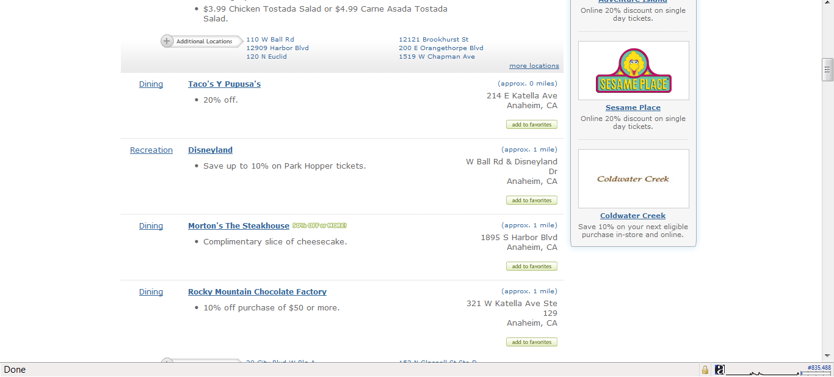
www.xtramanfundraising.com

