Redeeming Your $25 Restaurant Savings Certificate

Thank you for supporting the organization you bought your card from. Your support is going to help make their year one of their best ever!

SPECIAL BONUS!
Your purchase of the special Platinum MVP Fundraising Discount Card, also entitles you to receive a $25 Restaurant Savings Certificate. We have partnered with Restaurant.com to bring you this special bonus so you'll be able to choose from thousands of locations nationwide! (Conditions and restrictions apply.) This is, of course, in addition to all the other discounts that already come with your card. Remember, your card gives you access to discounts at over 300,000 locations all across the country.

This incredible bonus is only available to people like you who have purchased a Platinum MVP fundraising discount card and the phrase, "Receive a FREE $25 Restaurant Savings Certificate with purchase of this card." is printed on the back of the card. Make sure you have your card in front of you and then proceed to the instructions below.

To redeem your Savings Certificate:

1. Go to our special site for cardholders only at www.xtramancardholder.com

2. Click on the green Redeem My Certificate! button in the blue box in the top left corner of the page.

3. Fill out the required information in the blue box and click the orange Redeem My Certificate button.

4. You will receive an email with instructions on how to redeem your certificate.

5. Follow the instructions in the email and use the link to choose which restaurant(s) you want. You'll soon be enjoying a wonderful meal in appreciation of your generous support.

6. That's all there is to it, but if you have any questions about the Savings Certificate redemption, please call Xtraman Fundraising Customer Service at 1-800-405-6020 and we'll be happy to assist you.

On behalf of the organization you bought your card from . . . Thank You for Your Support!
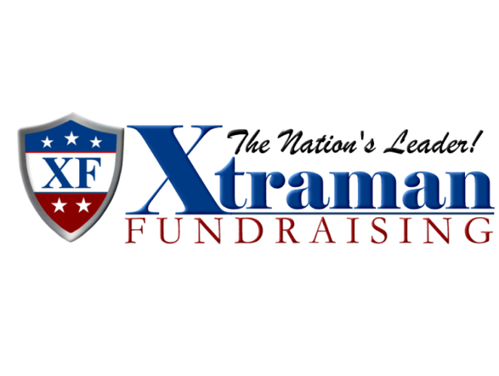
And from all of us here at Xtraman Fundraising . . . Bon Appetit!

www.xtramanfundraising.com

